|  |  |
| --- | --- |
| EGC_Black | **Eastern Goldfields College**  Mathematics Essentials 2019  Application 1 |
|  | Time allowed: 60 minutes Task Weighting: 9% |

**Investigation – Probability and Simulations**

Name: Mark: /21

* **Lead Up activity Booklet and scientific calculator allowed.**
* **Working is required for full marks for any question worth more than one mark.**

\_\_\_\_\_\_\_\_\_\_\_\_\_\_\_­­­­­­­\_\_\_\_\_\_\_\_\_\_\_\_\_\_\_\_\_\_\_\_\_\_\_\_\_\_\_\_\_\_\_\_\_\_\_\_\_\_\_\_\_\_\_\_\_\_\_\_\_\_\_\_\_\_\_\_\_\_\_\_\_\_\_\_\_\_\_\_\_\_\_\_\_\_\_\_\_\_

**The real thing**

For Oz Lotto 9 balls are randomly drawn from balls numbered 1 to 45. The first seven balls drawn are the winning numbers” and the last two numbers are the “supplementary numbers”

To win first division you need to match 7 numbers in a single game with the 7 winning numbers from the draw.

**The probability of choosing the correct 7 numbers is $\frac{1}{45379620}$**  or 0.00000002203

1. [4 marks]

Create a simulation to model Oz Lotto. Explain in detail

* Technique
* Explanation of method
* Non-Replacement accounted for
* Must have 45 balls/numbers

1. [2 marks]

Collect a Lotto ticket from your teacher. Run your simulation to see if you’ve won! Record your results below

* Result
* Marked Lotto ticket

1. [2 marks]

Identify and comment on a factor that may cause your simulation to no longer model the real world event.

* Any reasonable answer based on their simulation

1. [2 marks]

Using the lead up work you completed, comment on the relationship between the number of balls drawn and the chances of winning

* More balls = less chance
* Number of combinations increase

Consider the following information:

**Hot Numbers**

1 18 40 25 11 12

These numbers have been drawn most frequently.

**Cold Numbers**

14 44 2 17 35 30

These numbers have been drawn least frequently.

1. [2 marks]

What numbers would you choose and why?

* Any
* Equal chance

## Most Profitable Numbers

### Some numbers are statistically more profitable than others when they win.

This is because some numbers are less popular than others. When a less popular number is a winning number, fewer people share the prize which results in a larger dividend in that division.

#### Most Profitable Numbers

31 40 16 28 35 27

These numbers resulted in larger dividends.

#### Least Profitable Numbers

41 26 22 38 12 9

These numbers resulted in smaller dividends.

1. [2 marks]

What numbers would you choose and why?

* Any
* Equal chance

1. [2 marks]

Statistician Professor Peter Adams advises choosing unusual or unpopular numbers however, so that if you do win, there will be fewer other winners to share the spoils with.

“Lots of people pick their birthday as a lucky number, so I’d only ever pick numbers larger than 31”.

Comment on this statement.

* Probability is the same
* Higher amount **IF** they win

1. [3 marks]

What guidance might you give to someone who said;

“I have no money but it will be OK because I have been playing Lotto each week for 3 years so I know I will win soon!”

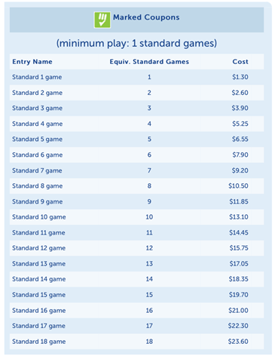

* Mentions probability doesn’t change per game
* Mentions cost associated with playing lotto
* Gives advice / guidance

1. [2 marks]

After sitting in Mr Cook’s math class the same person said;

“If I keep playing I will win soon because of the Law of Large Numbers”

Comment on the validity of this statement.

* Disagrees with statement
* States LLN to justify

End of Application

|  |  |  |  |  |  |  |  |
| --- | --- | --- | --- | --- | --- | --- | --- |
| Game 1 | 19 | 1 | 40 | 16 | 24 | 7 | 2 |
| Game 2 | 17 | 21 | 44 | 15 | 39 | 6 | 7 |
| Game 3 | 26 | 12 | 14 | 24 | 5 | 9 | 4 |
| Game 4 | 41 | 19 | 42 | 23 | 14 | 12 | 6 |
| Game 5 | 13 | 45 | 26 | 38 | 10 | 5 | 1 |
| Game 6 | 33 | 31 | 45 | 2 | 20 | 4 | 3 |
| Game 7 | 26 | 4 | 13 | 8 | 16 | 9 | 2 |

